**Capstone Project 1**

CMU-SE 450

**Project Plan**

**Version 1.3**

**Date: 28/04/2023**

**LinguaSnap for Travelers**

**Submitted by**

**Dat, Nguyen Thanh**



**Truong, Vu Dinh**

**Long, Pham Ba Hoang**

**Kha, Nguyen Ngoc**

**Approved by Nguyen Duc Man**

**Capstone Project 1- Mentor:**

Name Signature Date

**INTERNATIONAL SCHOOL OF DUY TAN UNIVERSITY**

**PROJECT INFORMATION**

|  |  |  |  |
| --- | --- | --- | --- |
| **Project acronym** | LiS | | |
| **Project title** | LinguaSnap for Travelers | | |
| **Start date** | 25 – February – 2023 | **End Date** | 31 – May – 2023 |
| **Lead institution** | International School, Duy Tan University | | |
| **Project mentor** | Nguyen Duc Man  Email: mannd@duytan.edu.vn  Phone: +84 904 235 945 | | |
| **Partner organization** | Duy Tan University | | |
| **Scrum Master** | Dat, Nguyen Thanh | ntdat1232001@gmail.com | 0972530969 |
| **Product owner** | Truong ,Vu Dinh | jonnyvu2210@gmail.com | 0905223611 |
| **Team members** | Kha, Nguyen Ngoc | winkha14567@gmail.com | 0945721427 |
| Long, Pham Ba Hoang | longphambahoang@gmail.com | 0793310221 |

**REVISION HISTORY**

|  |  |  |  |  |
| --- | --- | --- | --- | --- |
| **Version** | **Date** | **Comments** | **Author** | **Approval** |
| 1.0 | 12/04/2023 | Initial Release | All members |  |
| 1.2 | 09/04/2023 | Update Project plan | Kha |  |
| 1.3 | 28/04/2023 | Update project plan | Kha,Trường |  |

Table of Contents

1. PROJECT OVERVIEW 5

1.1. Purpose and Scope 5

1.1.1. Purpose 5

1.1.2. Scope 5

1.2. Assumptions and Constraints 5

1.3. Project Objectives 6

1.3.1 Standard Objectives 6

1.3.2 Specific Objectives 7

1.4. Critical Dependencies 8

1.5. Project Risk 8

2. PROJECT DEVELOPMENT APPROACH 9

2.1 Technical Process 9

2.1.1. Reasons for selecting 9

2.1.2. Agile Methodology 9

2.2. Quality Management 11

2.3. Unit Testing Strategy 14

2.4. Integration Testing Strategy 15

3. ESTIMATION 15

3.1. Size 15

3.3. Schedule 18

3.4. Resource 24

3.5. Infrastructure 25

3.6. Training Plan 25

4. PROJECT ORGANIZATION 26

4.1. Organization Structure 26

4.2. Project Team 28

5. COMMUNICATION & REPORTING 28

6. CONFIGURATION MANAGEMENT 29

7. SECURITY ASPECTS 29

# 

# PROJECT OVERVIEW

## Purpose and Scope

## Purpose

* The purpose of the LinguaSnap app is to facilitate communication and understanding between speakers of different languages. It allows users to enter text or speech in one language and get an accurate translation in another, helping to overcome language barriers and enabling communication in diverse linguistic contexts.
* Can be used in a variety of situations, such as when traveling abroad, communicating with people who speak another language, translating written documents, conducting business with international partners , study or research in a foreign language, ....

## Scope

* The scope of the LinguaSnap application can support a specific group of languages for translation, which can include common languages, less common languages or specialized languages depending on the target audience and use case. expected use.
* The translation application can provide different translation modes, such as text translation, speech translation or image translation.
* Text translation may involve entering text for translation, while voice translation may involve using speech recognition to translate spoken language.
* Image translation can involve translating text from images, such as signs or menus.

## Assumptions and Constraints

|  |  |  |
| --- | --- | --- |
| No | Description | Note |
| **Assumptions** | | | |
| 1 | Only SDK 24 or above versions supported.  Java version 8 or above | Scope |
| 2 | Customer reviewers will get seven days to approve a milestone document. If no comments are received within this time period, it will be considered as approved. | External Interfaces |
| Constraints | | | |
| 1 | The project is developed within 12 weeks and quarterly deployed on the market. | Schedule |
| 2 | The project shall conform to security requirements specified by the customer in the NDA | Security |
| 3 | The product operates at a high level of performance and has a page load of no more than 5 seconds. | Quality |
| 4 | The application operates on android 7.0 or aboves | Scope |
| 5 | The project will be implemented by a team consisting of 4 members | Resources |
| 6 | The financial estimation for the project is at a budget limit of $2248 | Budget |

## Project Objectives

## Standard Objectives

|  |  |  |  |
| --- | --- | --- | --- |
| Metrics | Unit | Committed | Note |
| Start Date | dd-mmm-yy | 25-2-2023 |  |
| End Date | dd-mmm-yy | 31-5-2023 |  |
| Duration | elapsed days | 99 days |  |
| Maximum Team Size | Person | 4 Person |  |
| Billable Effort | Person-day | 64 days |  |
| Number of work hours per day for one engineer | Person-hour | 8 hours |  |

|  |  |  |  |  |  |  |  |
| --- | --- | --- | --- | --- | --- | --- | --- |
| Metrics | Unit | Target | | | | Basic for setting Goals | |
| LSL | Average | USL |  | |
| Quality | | | | | | | |
| Customer Satisfaction | Point | 8.5 | 9 | 9.5 | Refer to Gx Target in the year 2020,  5% higher than previous project (A project) | |
| Leakage | Wdef/UCP |  |  |  |  | |
| Process Compliance | NC/Ob |  |  |  |  | |
| Cost | | | | | | | |
| Effort Efficiency | % | 70 | 80 | 90 |  | |
| Correction Cost | % | 60 | 65 | 70 |  | |
| Delivery | | | | | | | |
| Timeliness | % | 85 | 90 | 95 |  | |
| Requirement Completeness | % | 80 | 85 | 90 |  | |

## Specific Objectives

* Based on the needs of people when traveling or learning, we will build an app that can help users easily use according to their purposes.
* Integrate translation technology: Build and integrate an efficient translation technology to enable users to translate texts from one language to another, with high accuracy.
* Develop a search feature: Build a powerful search feature that allows users search for the related translated results on the Internet.
* User-friendly interface: Simple, easy-to-use and user-friendly user interface design, with clearly displayed search and translation features, makes it easy for users to interact with the application.
* Multi-Language Support: Supports many popular languages in the world, including English, French, Spanish, Chinese, Japanese and more, meeting the needs of multi-language translation of the user.
* Translation results storage and management: Provides translation results storage and management, allowing users to save previously used services and manage them easily.
* Confidentiality and privacy: Ensure the security and privacy of user data, and comply with legal regulations related to user data protection and personal information management.

## Critical Dependencies

|  |  |  |  |
| --- | --- | --- | --- |
| **No** | **Dependency** | **Expected delivery date** | **Note** |
| 1 | API of Google Cloud | 15-3-2023 | External system |
| 2 | Firebase | 15-3-2023 | External System |
| 3 | Google ML Kit | 15-3-2023 | External System |

## Project Risk

|  |  |  |  |  |
| --- | --- | --- | --- | --- |
| **Risk** | **Description** | **Probability** | **Impact** | **Mitigation Strategy** |
| Incorrect requirements | Developing the product which does not accord with the requirements | 3 | 5 | Discuss and communicate frequently with Stakeholders |
| Estimate working time | Actual working time is not enough to finish a task compared to the estimated previous time | 2 | 4 | Review old tasks and evaluations to estimate for the new task. Replan for each sprint. |
| People | Team member who is ill, has health problems, or busy | 4 | 3 | Notify the scrum master (or ask a colleague to help you)  Complete the assigned tasks when possible |
| Lack of technical experiences | Detect harmful content in the images is a difficult technique that all members need to research and develop. | 4 | 4 | Spend a lot of time for learning and training |
| Team Communication | Team members can conflict with each other while discussing something related to the project | 4 | 2 | Conduct a meeting to share knowledge, experience and learning methods |
| External problems | It has power problems, laptop, personal computer, network system | 3 | 3 | Find another workplace (library, coffee shop, ...)  Notify the scrum master to assign appropriate tasks |
| Market | Other products are deployed at the same time and compete with the project team's product | 2 | 3 | Develop newer features and organize promotional activities |

.

## PROJECT DEVELOPMENT APPROACH

## Technical Process

## Reasons for selecting

To keep up with today's increasingly changing technology trends, we want a truly flexible and easy project development model to adapt to that change. Our project will develop more new features in the future. We will continuously update and apply new technologies that increase the attractiveness and intelligence of the application.

Currently, our team is a small team with little experience in project development. Therefore, we cannot avoid problems that arise in the software development stages and requirements can be changed to be more suitable. For the traditional model that requires managerial skills and high accuracy, it will not suit our team. Applying Agile Scrum model will help us to solve these problems, bring a lot of experience and best performance for project development.

## Agile Methodology

Agile software development refers to a group of software development methodologies based on iterative development, where requirements and solutions evolve through collaboration between self-organizing cross-functional teams.

Agile software development is more than frameworks such as Scrum, Extreme Programming, or Feature-Driven Development (FDD).

Agile software development is more than practices such as pair programming, test-driven development, stand-ups, planning sessions, and sprints.

Agile software development is an umbrella term for a set of frameworks and practices based on the values and principles expressed in the Manifesto for Agile Software Development and the 12 Principles behind it. When you approach software development in a particular manner, it’s generally good to live by these values and principles and use them to help figure out the right things to do given your particular context.

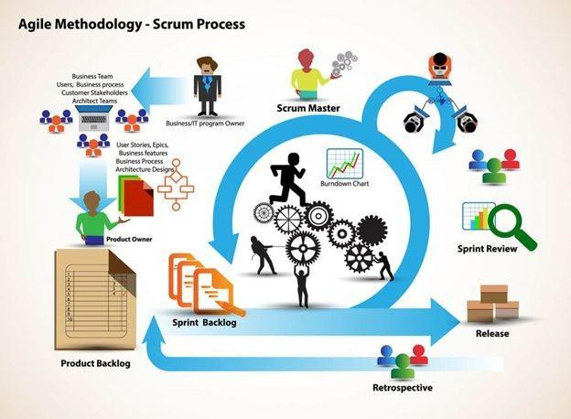**Scrum Process**

#### About Scrum:

Scrum is a subset of Agile. It is a lightweight process framework for agile development, and the most widely-used one.

Scrum is most often used to manage complex software and product development, using iterative and incremental practices. Scrum significantly increases productivity and reduces time to benefits relative to classic “waterfall” processes. Scrum processes enable organizations to adjust smoothly to rapidly-changing requirements and produce a product that meets evolving business goals.

An agile Scrum process benefits the organization by helping it to

* Increase the quality of the deliverables
* Cope better with change (and expect the changes)
* Provide better estimates while spending less time creating them
* Be more in control of the project schedule and state

## Quality Management

* + 1. **Estimates of Defects to be detected**

**Pre-release review defects**

|  |  |  |
| --- | --- | --- |
| **Process** | **Planned found by review** | **Actual found by review** |
| **Requirement** | 50 | 20 |
| <Work product> |  |  |
| **Design** | 30 | 25 |
| <Work product> |  |  |
| **Coding** | 180 | 150 |
| <Work product> |  |  |
| **Other** | 50 | 30 |
| <Work product> |  |  |
| Total | 310 | 225 |

**Pre-release test defects**

|  |  |  |
| --- | --- | --- |
| **Process** | **Planned found by review** | **Actual found by review** |
| **Requirement** | 35 | 25 |
| <Work product> |  |  |
| **Design** | 30 | 10 |
| <Work product> |  |  |
| **Coding** | 160 | 120 |
| <Work product> |  |  |
| **Other** | 40 | 25 |
| <Work product> |  |  |
| Total | 265 | 180 |

* + 1. **Strategy for Meeting Quality Objectives**

|  |  |
| --- | --- |
| **Strategy** | **Expected Benefits** |
| Do defect prevention using the standard defect prevention guidelines and process; use standards developed in Java for coding. | 15–25% reduction in defect injection rate and about 5% improvement in productivity |
| Group review of program specs for first few/logically complex use cases.  Group review of design docs/first time-generated code by project leader, developer, and one consultant. | Improvement in quality as overall defect removal efficiency will improve; some benefits in productivity as defects will be detected early |
| Introduction of RUP methodology and implementing the project in iterations. Milestone analysis and defect prevention exercise will be done after each Iteration. | Approximately 5% reduction in defect injection rate and 1% improvement in overall productivity |

* + 1. **Quality Control**

|  |  |  |  |  |  |  |  |  |  |
| --- | --- | --- | --- | --- | --- | --- | --- | --- | --- |
| **Review Item** | **Type of Review** | | **Reviewer** | | | **When** | | | |
| Proposal | Group review | | Man Nguyen, Long Pham, Truong Vu, Dat Nguyen, Kha Nguyen | |  | Initial | | | |
| Project plan Project schedule  Test Plan | Group review Group review  One-person review | | Long Pham, Truong Vu, Dat Nguyen, Kha Nguyen | | | End of Initiation stage | | | |
| Business analysis and requirements specification document, Use Case catalog | Group review | | Long Pham, Truong Vu, Dat Nguyen, Kha Nguyen | | | End of requirements | 90% | of | |
| Design document, object model | Group review | | Long Pham, Truong Vu, Dat Nguyen, Kha Nguyen | | | End of 90% design | | | |
| Stage plans | One-person review | | Man Nguyen | | | Beginning of each stage | | | |
| Complex/first specs incl.  Diagrams, Time test, Generaed cases, Program interactive | | Group review | | Man Nguyen, Long Pham, Truong Vu, Dat Nguyen, Kha Nguyen | | End of detailed design | | |
| Code | Group review | | Long Pham, Truong Vu, Dat Nguyen, Kha Nguyen | | | After coding for first few programs | | | |

* + 1. **Measurements Program**

|  |  |  |  |
| --- | --- | --- | --- |
| **Data to be collected** | **Purpose** | **Responsible** | **When** |
| Size: No. of KLOC/ FP | Early estimate project cost | PM/SM | At the end of stages |
| Effort: No. person-day | Calculate project effort for scheduling | Team members | Daily |
| Quality: No. defects detected | Early evalute product quality and the feasibility of the project | Reviewer, Tester | Right after the review/test |
| Schedule | Divide work and allocate resources properly, ensure the project is completed on time and on budget | PM/SM | Weekly and at the end of stages |

## Unit Testing Strategy

* Grey Box:
  + It is a combination of a Black Box and White Box testing. It is the type of testing in which tester aware with internal functionality of a method or unit but not in a more deep level like white box testing. In this, the user partially aware of the internal functionality of a system.
  + Write test cases before fixing the defect and independent of each other.
  + Write cases to verify behavior, also write test cases to ensure the performance of the code
  + Execute test cases continuously and frequently.
  + Using tool: Install and run Jest for writing unit test in NodeJS
* Isolation of a code – Isolate function to test it more rigorously. Isolate code to do Automated Unit Testing in a better way. Isolating functions/code helps to do testing in a good way. It helps to reveal dependencies between functions of code.

## Integration Testing Strategy

* Bigbang Strategy:
  + All components are put together at the same time, there is no order, except all are integrated at the same time.
  + Towards the end of the project, we started to apply this tactic to test the entire application.

# ESTIMATION

## Size

* Total number of FP: 68

|  |  |
| --- | --- |
| **Software Scale Drivers** | |
| Precedent | Nominal |
| Development Flexibility | Nominal |
| Architecture / Risk Resolution | Nominal |
| Team Cohesion | Very High |
| Process Maturity | Nominal |

|  |  |  |  |
| --- | --- | --- | --- |
| **Software Cost Drivers** | | | |
| **Product** | | **Personnel** | |
| Required Software Reliability | Nominal | Analyst Capability | High |
| Data Base Size | Nominal | Programmer Capability | High |
| Product Complexity | Nominal | Personnel Continuity | Nominal |
| Developed for Reusability | High | Application Experience | High |
| Documentation Match to Lifecycle Needs | Nominal | Platform Experience | High |
|  | | Language and Toolset Experience | High |
| **Project** | | **Platform** | |
| Use of Software Tools | High | Time Constraint | Nominal |
| Development | Nominal | Storage Constraint | Nominal |
| Required Development Schedule | Nominal | Platform Volatility | Nominal |

**Software Development (Elaboration and Construction)**

Cost per Person-Month (Dollars) = 60,789 $

Resource = 4 person.  
 Effort = 7.6 Person-months.  
 Schedule = 64 Day = 2.13 Months.

Other cost = 400 USD.  
 Cost = Effort * Schedule + Other cost = $2248   
 Total Equivalent Size = 3604 SLOC  
 Effort Adjustment Factor (EAF) = 0.65

|  |  |  |  |  |  |  |  |  |  |  |  |  |  |  |  |  |  |  |  |  |  |  |  |  |  |  |
| --- | --- | --- | --- | --- | --- | --- | --- | --- | --- | --- | --- | --- | --- | --- | --- | --- | --- | --- | --- | --- | --- | --- | --- | --- | --- | --- |
| **Acquisition Phase Distribution**   |  |  |  |  |  | | --- | --- | --- | --- | --- | | Phase | Effort (Person-months) | Schedule (Months) | Average Staff | Cost (Dollars) | | Inception | 0.6 | 1.0 | 0.6 | $120 | | Elaboration | 2.3 | 2.9 | 0.8 | $350 | | Construction | 7.3 | 4.8 | 1.5 | $1558 | | Transition | 1.1 | 1.0 | 1.2 | $220 | |  |

**Software Effort Distribution for RUP/MBASE (Person-Months)**

|  |  |  |  |  |
| --- | --- | --- | --- | --- |
| Phase/Activity | Inception | Elaboration | Construction | Transition |
| Management | 0.1 | 0.3 | 0.7 | 0.2 |
| Environment/CM | 0.1 | 0.2 | 0.4 | 0.1 |
| Requirements | 0.2 | 0.4 | 0.6 | 0.0 |
| Design | 0.1 | 0.8 | 1.2 | 0.0 |
| Implementation | 0.0 | 0.3 | 2.5 | 0.2 |
| Assessment | 0.0 | 0.2 | 1.7 | 0.3 |
| Deployment | 0.0 | 0.1 | 0.2 | 0.3 |

* 1. **Effort**

The Effort estimation

|  |  |  |  |  |  |  |  |  |  |
| --- | --- | --- | --- | --- | --- | --- | --- | --- | --- |
| **Activity**  **/Process** | **Total budgeted Effort Usage (USD)** | **Total % budgeted Effort Usage (%)** | **Sprint 1** | | **Sprint 2** | | **Sprint 3** | | |
| **USD** | **%** | **USD** | **%** | **USD** | **%** |
| Requirement | 100 | 5,96 | 50 | 11,41 | 50 | 5,32 | 0 | 0.00 |
| Design | 200 | 14,9 | 100 | 15,21 | 50 | 15,21 | 50 | 14,14 |
| Coding & Unit Testing | 1298 | 34,44 | 500 | 26,62 | 400 | 35,71 | 398 | 42,98 |
| Testing | 250 | 13,41 | 123 | 9,89 | 50 | 15,31 | 77 | 16,02 |
| Deployment | 100 | 2,98 | 25 | 1,90 | 25 | 2,55 | 50 | 4,71 |
| Support for Acceptance Test | 50 | 4,47 | 20 | 3,80 | 15 | 5,10 | 15 | 4,71 |
| Project Planning | 50 | 2,98 | 20 | 3,80 | 15 | 2,55 | 15 | 2,36 |
| Project Review | 100 | 5,96 | 60 | 4,56 | 35 | 8,16 | 5 | 5,66 |
| Training | 100 | 14,9 | 50 | 22,81 | 30 | 10,20 | 20 | 9,43 |
| **Total** | 2248 | 100 | 948 | 100.00 | 670 | 100.00 | 630 | 100.00 |

## Schedule

* + 1. **Project Milestone & Deliverables**

|  |  |  |  |  |
| --- | --- | --- | --- | --- |
| **NO** | **Task Name** | **Duration** | **Start** | **Finish** |
| **1** | Initial | 4 | 25/02/2023 | 03/03/2023 |
|  | Gathering Requirement | 3 | 27/02/2023 | 02/03/2023 |
|  | Create Proposal Document | 1 | 03/03/2023 | 03/03/2023 |
| **2** | Start Up | 3 | 06/03/2023 | 08/03/2023 |
|  | Create documents for project | 3 | 06/03/2023 | 08/03/2023 |
| **3** | Development | 56 | 09/03/2023 | 26/05/2023 |
|  | Sprint 1 | 21 | 09/03/2023 | 07/04/2023 |
|  | Sprint 2 | 21 | 08/04/2023 | 09/05/2023 |
|  | Sprint 3 | 14 | 10/05/2023 | 30/05/2023 |
| **4** | Project’s Retrospective Meeting and final release | 1 | 31/05/2023 | 31/05/2023 |
| **5** | Total | 64 |  |  |

* + 1. **Work Breakdown Structure**

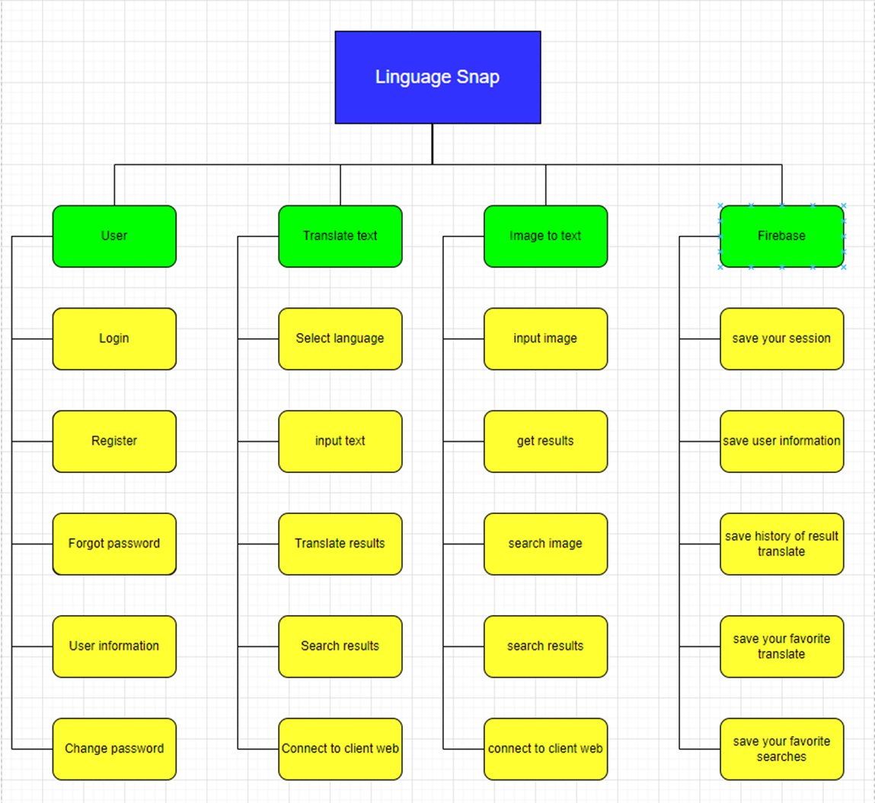

* + 1. **Detailed Schedule**

|  |  |  |  |  |  |
| --- | --- | --- | --- | --- | --- |
| **No.** | **Task Name** | **Duration (Days)** | **Start** | **Finish** | **Assign to** |
| **1.** | **Initial** | 7 | 25/02/2023 | 08/03/2023 | Team, Mentor |
| 1.1 | Project’s Kick-off Meeting | 1 | 27/02/2023 | 27/02/2023 | Team, Mentor |
| 1.2 | Collect and analyze requirements | 1 | 28/02/2023 | 01/03/2023 | Team |
| 1.3 | Setup Development Environment | 1 | 02/03/2023 | 02/03/2023 | Team |
| 1.4 | Research Technical | 1 | 03/03/2023 | 03/03/2023 | Team |
| 1.5 | Create documents | 3 | 06/03/2023 | 08/03/2023 | Team |
| **2** | **Development** | 56 | 09/03/2023 | 26/05/2023 | Team |
| 2.1 | Sprint 1 | 21 | 09/03/2023 | 07/04/2023 | Team |
| 2.1.1 | Design App Theme |  |  |  | Team |
| 2.1.2 | Code OCR API |  |  |  | Team |
| 2.1.3 | Crop Image |  |  |  | Team |
| 2.1.4 | Take full-scale Image |  |  |  | Team |
| 2.1.5 | Code Firebase Authentications |  |  |  | Team |
| 2.1.6 | Basic Login |  |  |  | Team |
| 2.1.7 | User Register |  |  |  | Team |
| 2.1.8 | Login Sessions |  |  |  | Team |
| 2.1.9 | Forgot password |  |  |  | Team |
| 2.1.10 | Code Translate API |  |  |  | Team |
| 2.1.11 | Spinner List selection |  |  |  | Team |
| 2.1.12 | Auto Detect Language |  |  |  | Team |
| 2.1.13 | Code App UI |  |  |  | Team |
| 2.1.14 | Integrate into basic app |  |  |  | Team |
| 2.1.15 | Update Project Plan |  |  |  | Team |
| 2.1.16 | Update Product Backlog |  |  |  | Team |
| 2.1.17 | Create Sprint Backlog |  |  |  | Team |
| 2.1.18 | Sprint meeting |  |  |  | Team |
| 2.1.19 | Sprint Retrospective |  |  |  |  |
| 2.2 | Sprint 2 | 21 | 08/04/2023 | 09/05/2023 | Team |
| 2.2.1 | Search Image |  |  |  | Team |
| 2.2.2 | Data Collection |  |  |  | Team |
| 2.2.3 | Auto-Translate |  |  |  | Team |
| 2.2.4 | Update Integrated App |  |  |  | Team |
| 2.2.6 | Update Architecture Document |  |  |  | Team |
| 2.2.7 | Update Database Design |  |  |  | Team |
| 2.2.8 | Update User Interface Design |  |  |  | Team |
| 2.2.9 | Update Sprint Backlog |  |  |  | Team |
| 2.2.10 | Text to Speech API |  |  |  | Team |
| 2.2.11 | Speech to Text API |  |  |  | Team |
| 2.2.12 | Setup character limit |  |  |  | Team |
| 2.2.13 | Dictionary API |  |  |  | Team |
| 2.2.14 | Save used languages |  |  |  | Team |
| 2.2.15 | Spell checker API |  |  |  | Team |
| 2.2.16 | Update Main page design |  |  |  | Team |
| 2.2.17 | Search text result |  |  |  | Team |
| 2.2.18 | Design “Image to text” page |  |  |  | Team |
| 2.2.19 | Translation History |  |  |  | Team |
| 2.2.20 | Change password |  |  |  | Team |
| 2.2.21 | Design Login/Forgot password/Register page |  |  |  | Team |
| 2.2.22 | Design menu in main  page |  |  |  | Team |
| 2.2.23 | Sprint meeting |  |  |  | Team |
| 2.2.24 | Sprint Retrospective |  |  |  | Team |
| 2.3 | Sprint 3 | 14 | 10/05/2023 | 30/05/2023 | Team |
| 2.3.1 | Bookmark |  |  |  | Team |
| 2.3.2 | View/Edit user information |  |  |  | Team |
| 2.3.3 | Swap languages |  |  |  | Team |
| 2.3.4 | Copy translated text |  |  |  | Team |
| 2.3.5 | Fix bug/Error |  |  |  | Team |
| 2.3.6 | Update Test Case |  |  |  | Team |
| 2.3.7 | Update User Story |  |  |  | Team |
| 2.3.8 | Update Integrated App |  |  |  | Team |
| 2.3.9 | Sprint meeting |  |  |  | Team |
| 2.3.10 | Sprint Retrospective |  |  |  | Team |
| 2.3.11 | Wrapping up app project |  |  |  | Team |
| 2.3.12 | Update and Finalize Sprint Backlog |  |  |  | Team |
| **3** | **Delivery and close project** | **1** | 31/05/2023 | 31/05/2023 | Team, mentor |

* + 1. **Project Schedule**

The detail project schedule is available in The Sprint Backlog.

## Resource

|  |  |  |
| --- | --- | --- |
| **Position** | **Member** | **Effort** |
| Back-end Developer | All Member |  |
| Front-end Developer | All Member |  |
| Designer | All Member |  |
| Data Engineer | All Member |  |
| Tester | All Member |  |

## Infrastructure

|  |  |  |  |
| --- | --- | --- | --- |
| **Work/Product** | **Purpose** | **Expected Availability by** | **Note** |
| **Development Environment** | | | | |
| Windows 11 | Operating System | Initiation stage |  |
| Google Cloud | Flatform | Initiation stage |  |
| Android Studio | IDE | Initiation stage |  |
| Firebase | DBMS | Initiation stage |  |
| Java | Development language for native Android develop | Initiation stage |  |
| **Hardware & Software** | | | | |
| 4 Personal Laptop | Design, Develop and emulation | Initiation stage |  |
| 2 Android phone | Testing | Initiation stage |  |
| **Other Tools** | | | | |
| Git | Source version control | Definition stage |  |
| Trello | Task tracking | Initiation stage |  |

## Training Plan

|  |  |  |  |
| --- | --- | --- | --- |
| **Training Area** | **Participants** | **When, Duration** | **Waiver Criteria** |
| Technical | | | |
| Java Language | All members | 7 days | If already trained |
| Detect harmful contents | All members | 10 hrs | If already trained |
| Firebase | All members | 5 hrs | Mandatory |
| Process | | | |
| Quality system | All members | 3 hrs | If already trained |
| Configuration management(Git and bitbucket tool) | All members | 2 hrs | If already trained for  CC. For others, on-the- job training |
| Group review | All members | 4 hrs | If already trained |
| Defect prevention | All members | 4.5 hrs | Mandatory |
| UI Automator | All members | 4.5 hrs | If already trained |
| Agile Scrum | All members | 2 hrs | Mandatory |

# PROJECT ORGANIZATION

## Organization Structure

|  |  |  |
| --- | --- | --- |
| **Role** | **Responsibility** | **Name** |
| **Scrum Master** | * Communicate the value of Scrum * Teach the organization on Scrum to maximize business value * Preserve the integrity and spirit of the Scrum framework * Serve as a coach and mentor to members of the Team * Respectfully hold the Team, Product Owner and Stakeholders accountable for their commitments * Continually work with the Team and business to find and implement improvements * As a timekeeper * Helping the team agree on what they can achieve during each development sprint (or other period of time). * Facilitating the daily standup (sometimes called the daily scrum) and helping the team reach consensus on each of the three questions. * Helping the team continuously make progress on the project by making sure each person is working on the right tasks, helping to remove any obstacles to the team members’ progress, and protecting the team from distractions. |  |
| **Product Owner** | * A spokesperson for the customer and needs to represent them * Gathers, manages, and prioritizes the product backlog. * Has technical product knowledge or specific domain expertise. * Tracks progress towards the release of a product. |  |
| **Developer** | * Responsible for quality * Responsible for delivering the potentially shippable product of the Application each sprint * Report progress based on the remaining time * Self-organized * Owns the Sprint backlog | All members |
| **Mentor** | * Guide on the process. * Monitoring all activities of the Team. * Help with anything. * Reviews project documents   - Reviews product | Man, Nguyen Duc |

## Project Team

|  |  |
| --- | --- |
| **Full Name** | **Position** |
| Man, Nguyen Duc | Mentor |
| Dat. Nguyen Thanh | Scrum Master, Dev-team |
| Truong, Vu Dinh | Product Owner, Dev-team |
| Long, Pham Ba Hoang | Dev-team |
| Kha, Nguyen Ngoc | Dev-team |

# COMMUNICATION & REPORTING

|  |  |  |  |
| --- | --- | --- | --- |
| **Audience / Attendees** | **Topic / Deliverable** | **Frequency** | **Method** |
| Scrum Master, Members | Daily meeting | Daily | Face to Face / Zoom Meeting / Slack Chat |
| Scrum Master, Members | Sprint Planning Meeting | When starting a sprint | Zoom Meeting |
| Scrum Master, Members, Mentor | Sprint Review Meeting | When finishing a sprint | Face to face, Zoom Meeting |
| Scrum Master, Members | Sprint Retrospective | When the sprint review finish | Face to Face |
| Scrum Master, Members | Individual Meeting | When need | Face to Face, Zoom Meeting, Message |
| Scrum Master, Members, Mentor | Working report, review problems | Once a week | Face to face |

# CONFIGURATION MANAGEMENT

Github link: https://github.com/ismekakawin9/LinguaSnap/branches

# SECURITY ASPECTS

* The credential data is carefully secured by multi-layer encryption and data integrity is ensured. Regularly back up system data.
* Research on network attack prevention solutions to ensure data security, avoid being exploited and stolen data by hackers.
* Deploy project architecture with a high priority in security. Optimized architectural solutions enable the deployment of data security with 99% reliability.
* Social media, sharing and use of data must be approved by the end user and verified by the organization's management.

**REFERENCES**

|  |  |  |  |  |
| --- | --- | --- | --- | --- |
| **No** | **Reference item** | **Issued Date** | **Source** | **Note** |
| 1 | Agile Scrum | 04-Apr-21 | <https://www.atlassian.com/agile> |  |
| <https://www.cprime.com/resources/what-is-agile-what-is-scrum/> |  |
| <https://www.agilealliance.org/agile101/> |  |
| The Scrum Framework by International Scrum Institute |  |
| 2 | COCOMO II | 04-Apr-21 | <https://www.rose-hulman.edu/class/csse/csse372/201410/SlidePDFs/session12.pdf> |  |
| 3 | Software Standards | 05-Apr-21 | [https://www.nws.noaa.gov/oh/hrl/developers_docs/General_So](https://www.nws.noaa.gov/oh/hrl/developers_docs/General_Software_Standards.pdf) [ftware_Standards.pdf](https://www.nws.noaa.gov/oh/hrl/developers_docs/General_Software_Standards.pdf) |  |
| <https://standards.ieee.org/standard/12208-2017.html> |  |
| <https://sw-eng.larc.nasa.gov/> |  |

**DEFINITIONS AND ACRONYMS**

|  |  |  |
| --- | --- | --- |
| **Acronym** | **Definition** | **Note** |
| PM | Project Manager |  |
| PTL | Project Technical Leader |  |
| QA | Quality Assurance Officer |  |
| CC | Infrastructure Configuration Controller |  |
| DV | Developer |  |
| URD | User Requirement Document` |  |
| ADD | Architecture Design Document |  |
| TP | Test Plan |  |
| TC | Test Case |  |
| SC | Source Code |  |
| CM | Configuration Management |  |
| CI | Configuration Item |  |